**MenGO: An Artificial Intelligence, Data Science & Analytics, Bioinformatics and Blockchain Powered Novel Cloud-based Digital Healthcare Platform for Andrology**

**Raj Ray1,5, Zack Agar1, Pratik Dutta2, Sreetam Ganguly1,4, Debarshi Roy3**

1 SystemOnSilicon Corporation, TX (www.systemonsilicon.com)

2 Stony Brook University, Stony Brook, NY

3 Department of Biology, Alcorn State University, Lorman, MS

4 Indian Institute Of Engineering Science and Technology (IIEST), India

5 The University of Texas at Austin, TX, USA

**ABSTRACT**

Digital innovation & transformation, a technology revolution triggered by the latest advancements in the IT sector, has redefined a number of socially significant domains including healthcare, agriculture, food, finance, and education since the turn of this millennium. Although the power of digital technology has played a key role in modernizing many areas of the healthcare arena, a critical sub-category like andrology i.e., sexual and reproductive health of men, is yet to reap the full benefit of digitalization. This paper describes and explains how MenGO, the world’s 1st data science and analytics powered digital healthcare solution for andrology, is ushering in a new era of men’s health, a traditionally neglected domain, with innovative applications of cutting-edge technologies such as artificial intelligence, machine & deep learning, natural language processing, bioinformatics, blockchain, and cloud computing. MenGO offers custom recommendations, contextual guidance, smart alerts, in-depth report analytics, and statistical guidance for physicians, health institutions, biomedical researchers, pharma houses, insurance companies, and common users. The data analytics engine of MenGO helps users with personalized analytics, physicians with predictive and prescriptive analytics, and caregiving institutes with demographic analytics. A one-stop solution for men suffering from chronic ailments like erectile dysfunction, infertility, ejaculation problems, prostate gland issues, etc. MenGO helps users access affordable physiological and psychological treatments through its cloud and big data analytics powered smart and interactive telehealth platform.

**Keywords**: Artificial Intelligence, Machine Learning, Deep Learning, Natural Language Processing, Andrology, Digital Healthcare, Bioinformatics, Genomics, Blockchain, Cloud

**INTRODUCTION**

1. **Background**

Andrology is the medical specialty that deals with sexual and reproductive health issues of men and urological problems that are unique to men. Although it is the counterpart to gynecology, a major medical domain that focuses on sexual, reproductive, and urological health issues of women, andrology has not been as widely covered, discussed, or explored as gynecology. Through ages the domain of andrology care has been addressing a number of chronic health problems with far-reaching consequences but has never received the global attention it deserves due to factors such as shortage of physicians with expertise in andrology, lack of general awareness about andrology, inadequate emphasis on andrology from medical bodies, etc. In many societies, people hesitate to talk about such ailments due to social stigmas and superstitions. Since the ecosystem of andrology care is not properly established in many parts of the world, people suffering from commonly occurring andrological diseases e.g., erectile dysfunction, male infertility, ejaculation problems, etc. seldom find proper medical guidance or support they absolutely need. They cannot openly discuss their issues with close family members and friends since this entire domain is wrongly treated as a taboo in many societies. Therefore, patients continue living under stress and often get into depression which may lead to disastrous consequences. It has been observed that a large segment of these victims can easily get trapped and exploited by illegitimate and unlicensed medical practitioners who can worsen the situation. The fact that the world needs a robust, sustainable, and scalable solution for andrology is beyond any reasonable doubt. In order to solve this critical challenge, SystemOnSilicon Corporation, a high-tech venture founded by a group of leaders from medical science, biology, software, and hardware, has created MenGO– an AI-powered mobile application. MenGO is the world's 1st digital health platform for andrology care. The goal of this paper is to narrate the problem, substantiate it with figures and statistics, provide an overview of the current gap in the solution landscape, define the problem from a scientific standpoint, describe the pioneering digital health solution proposed by SystemOnSilicon Corporation to solve the lacuna with illustrations, furnish experimental results and summarize with future directions and a conclusion.

1. **Landscape Analysis**

According to recent surveys and investigations, around 322 million people may suffer from erectile dysfunction by 2025, about 30-40 % of men across the world suffer from premature ejaculation, infertility affects approximately 15% of couples globally and about 1 man in 8 will be diagnosed with prostate cancer during his lifetime. Since the turn of this millennium digital health tech, an emerging interdisciplinary domain that blends medical science with information technology has brought radical changes in multiple domains of healthcare such as medical imaging, personalized care, wearable devices, record management, prescriptive and predictive analytics, disease detection, drug discovery, etc. However, andrology is yet to get blessed by this ongoing digital revolution powered by rapid advancements in artificial intelligence, machine & deep learning, the internet of things, cloud computing, big data analytics, natural language processing, bioinformatics, and full-stack solutions. Our goal is to change that scenario by introducing digital innovation & transformation in andrology.

1. **Previous Work**

The domain of sexual and reproductive health issues has always been a sensitive and complicated topic in many countries. Unfortunately for years, advanced medical research in andrology and modern technology solutions for men’s sexual problems have always faced such roadblocks even in advanced countries. Traditionally in most health care centers, gynecologists and urologists handled andrological problems but the situation is changing at a rapid pace. The medical and biological research communities have understood the importance of further investigations in andrology and associated complications. In the following sections, we have highlighted a few examples to showcase the current global landscape of Andrological research for erectile dysfunction and male infertility:

* **Erectile Dysfunction**

Erectile dysfunction (ED) is one of the major clinical conditions for impotence which is defined by an inability to get and keep an erection firm enough for sex. Pizzol et. al [1] highlights some recent developments in ED research and shows how ED is connected to other underlying health problems. Hui et.al [2] presents a chronological history of ED research and their impacts. It has been found that the prevalence level of severe and moderate ED was 5 and 17%, respectively, in men in the 40–49 age group while in men aged 70–79 years they were 15 and 34%. Furthermore, we have narrowed down the recent findings on ED to provide a comprehensive analysis of the research landscape for ED [3-22]. It is evident that underlying medical conditions such as type-II diabetes or obesity or cardiovascular conditions may have a direct or indirect impact on ED. Lack of physical exercises may aggravate the severity of ED [3,13]. A properly balanced diet with a moderate range of regular physical activities is reported to be effective against ED.

* **Male Infertility**

In a recent report published in the Journal of human reproductive sciences [24] the prevalence of male infertility at a global scale and in the Indian sector has been discussed with some statistical reports which emphasize the rise in infertility issues in modern society. One major reason behind infertility is the inability of the hormone-producing cells to synthesize androgen hormones leading to infertility [24]. The lack of hormone receptors due to post-translational modifications or mutations is also believed to have an impact on male infertility [25]. Multiple research and development activities including hormonal therapy, treating underlying diseases, tackling psychotic issues, etc., are underway to find the cure for male infertility [26,27].

1. **Why do we need MenGO?**

Today quite a few mobile and web apps have come up that focus on different areas of the healthcare sector including, cancer detection, lung disease analysis, nutrition, health record management, hospital administration, doctor booking, child care, diagnostic analysis, etc. However, no such digital health solution was available for andrology when we started developing MenGO. Even today MenGO is the only full-fledged digital solution for Andrology. MenGO is not only the 1st andrology app in the world that offers personalized care, smart recommendations, contextual alerts, and detailed health analytics, it also is a pioneer in offering telehealth consultation, community support, and predictive guidance for physiological as well as mental problems related to andrology and created by andrology. In a world suffering from a catastrophic pandemic, we believe MenGO will add some extremely important values to the global healthcare landscape as the 1-stop digital health platform for andrology.

**METHODS**

1. **Problem statement**

Andrology is the medical specialty dealing with men’s health and reproductive system, including the hormonal, reproductive, sexual, as well as psychological aspects, from birth to adulthood. Regular andrological checkups are essential both to reveal possible problems and to receive thorough advice and information so as to ensure that sexual and reproductive functions are well preserved. Estimates report that about one in three males suffers from andrological diseases, their rates varying according to the age: 27–30% of pediatric male subjects have reproductive and/or sexual conditions. In adulthood, 40% of men are affected by andrological diseases, in particular infertility. These problems may cause considerable social, emotional, and psychological stress between couples, among families, within the individual, concerned, and the society at large. This depression leads to fatigability in patients and this poor self-esteem affects normal sexual functioning. Along with this, in India, speaking about andrological problems is considered taboo. Rather most people are rarely formally aware of sexual health, leading to the perpetuation of multiple myths and misconceptions. The patient's awkwardness and the physician's difficulty in handling andrological issues often make both parties reluctant to discuss sexual problems. In this modern time, though there are a lot of health-related apps, there is no cloud-based app that provides telehealth support or can recommend any personalized solutions.

1. **Proposed Solution**

Based on our in-depth domain research, landscape exploration, and competitive analysis, we clearly understood that millions of individuals suffering from chronic andrological diseases would desperately need an intelligent, farsighted, and interactive digital health platform that could help them with timely and comprehensive answers, suggestions and recommendations for complex physiological as well as psychological symptoms. In addition, they might need to consult with medical experts but the pandemic situation would surely make that a difficult proposition. In addition, a healthcare platform of this nature should also ensure that patients’ medical records, consultation details, and health updates would be managed in a safe and secure manner. Considering all these requirements and nuances with the utmost care, SystemOnSilicon has launched MenGO – Act with Confidence, a disruptive digital health platform for Andrology. Salient features of MenGO include personalized care, contextual guidance, telehealth consultation, mental health support, predictive recommendations, smart alerts, interactive chatbot, and more.

1. **Technology Stack**

To tackle the above-mentioned problems, we have utilized an artificial intelligence based approach to develop a cloud-based telehealth app that can provide personalized solutions for andrological solutions. This AI-based cloud app can help the users to connect the renowned andrological doctors and along with that it also helps the users how to deal with physiological problems. In this app, we have also provided an artificial intelligence-based personalized chatbot that assists users to receive personalized recommendations for their problems. This chatbot is developed by analyzing the large datasets of health and anatomical data using various natural language processing methods. The database which is used for training the model is curated and maintained by the domain experts in the field of Andrology. This huge knowledge base and the sophisticated algorithms of the AI helps to develop a personalized chatbot for the user.

MenGO – Act with Confidence, an end-2-end 1-stop health-tech platform for andrology care, is built with a host of digital technologies such as cloud computing, full-stack applications, artificial intelligence, machine & deep learning, natural language processing, big data analytics, bioinformatics, and blockchain. MenGO is a groundbreaking innovation that clearly demonstrates how a socially responsible high-tech R&D venture can intelligently apply *digital innovation and transformation* to redefine andrology, a less explored medical domain, and usher in a new era of digital healthcare for generations to come.

**RESULTS**

1. **Experimental Outcomes and Analysis**

In this section, the results of the proof of concept MenGO are discussed. A data analytics and NLP-driven approach results in a more targeted personalized healthcare experience for the average user. MenGO, our smart digital health platform, with its pragmatic approach in dealing with andrological issues, has resulted in a much more streamlined medical consultation procedure. A big feature of MenGO, its chatbot, enables users to maintain a certain level of privacy, while at the same time, getting constant support from specialists in the domain of Andrology. In the case of specialist consultations, doctors need not be online all the time, since a certain part of the process is handled by autonomous chatbots. The continual updating of chatbots by Natural Language Processing, Long Short Term Memory and Generative Adversarial Networks results in a Negative Logistic Human Interaction (NSHI) where the fraction of time spent per patient per doctor per day follows a version of the logistic curve, defined as

$D(t)=1-(1+e{}^{B(m-t)}){}^{-\frac{1}{ν}}$

Where,

D is the fraction of the time spent by a human, advising a patient

B is the decrease rate

m is the starting time (in days)

t is the time (in days)

$ν$ affects the point at which the maximum change occurs. It is non-zero, positive, and real.

Employing such a feature also enables the user to save the hassle of reaching out to doctors in person. Keeping in mind the relatively recent health crisis faced around the world due to COVID-19, such a feature, in which patients do not have to leave the comfort of their home to visit clinics (which can often result in superspreader incidents) is found to be a quite welcome nuance. On average, patients found MenGO to be approximately 5-10% cheaper when compared to in-person clinic visits, while doctors and clinics found this app to increase ROI by approximately 2.7-5%. Such a bump in savings can also reflect in the reduction in carbon emissions and reduction in the time spent by patients in commute and public transportation between residence and clinics.

A retrieval-based process enables the user to get recommendations according to his nationality and ethnicity. This has resulted in a quicker recommendation process. The knowledge base of the chatbot gives instant recommendations, health tips and clears frequent doubts in the minds of patients quicker than an internet search. It also reduces the risk of entrapment by false information, that runs rampant in the modern internet landscape. This is a huge advantage for patients who have preventable or manageable health conditions, such as obesity, stress and hypertension, high blood cholesterol, etc., affecting their sexual well-being.

Patients’ medical histories are kept secure using blockchains and secure end-to-end encryption. This is critical in maintaining the privacy of patients. These medical histories are properly managed and provided to the doctor or the chatbot while consultation. This feature streamlines the process of cross integration between standard hard-copy and digital prescriptions and digital medical histories. Such integration has been repeatedly proved tricky to achieve, by traditional public health champions. However, MenGO achieves this easily and maintains a detailed ledger of every patient, which makes its consultation process extremely easy. Approximately 70% of users favor this method. This method of cross-platform and cross technical integration of medical histories, using both hard copy and soft copy of prescription has been particularly successful in India, where individuals are becoming increasingly reliant on a decentralized healthcare system. Patients are observed to get a traditional consultation from the app and use the soft copy of the prescription to buy medication from online pharmacies or print out hard copies for administrative purposes (including sign-up and pre-processing for insurance and corporate healthcare policies) or procuring medications over the counter from pharmacies.

1. **MenGO - Act With Confidence**

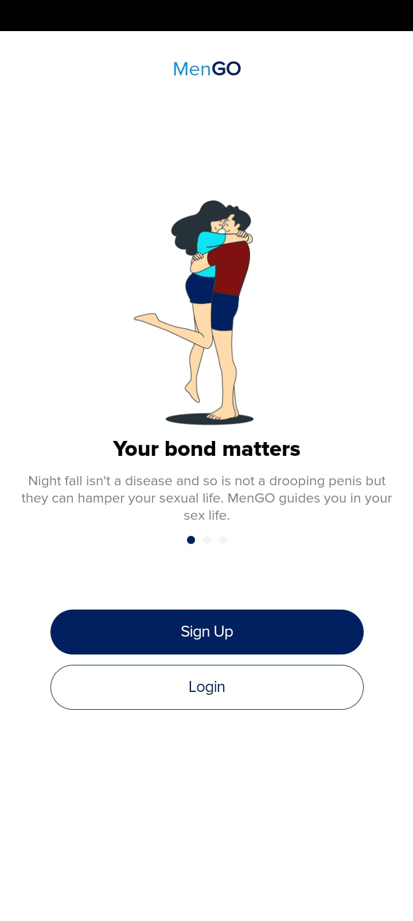 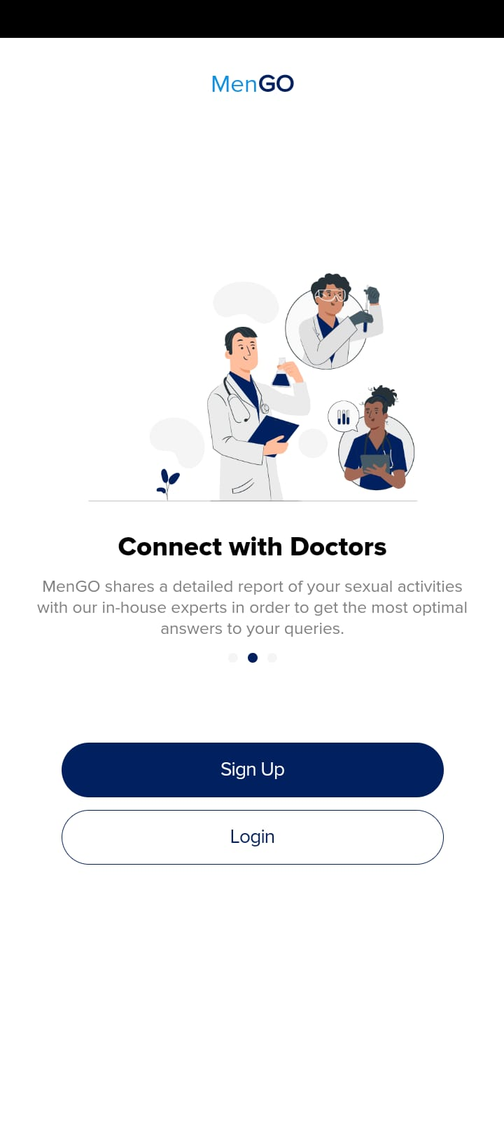

*(a) (b)*

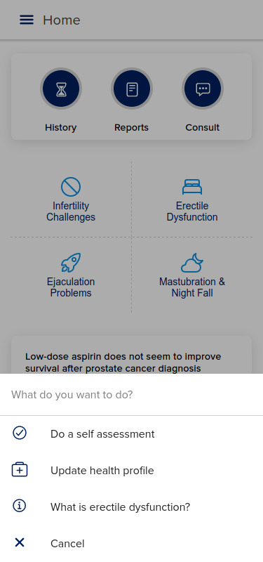 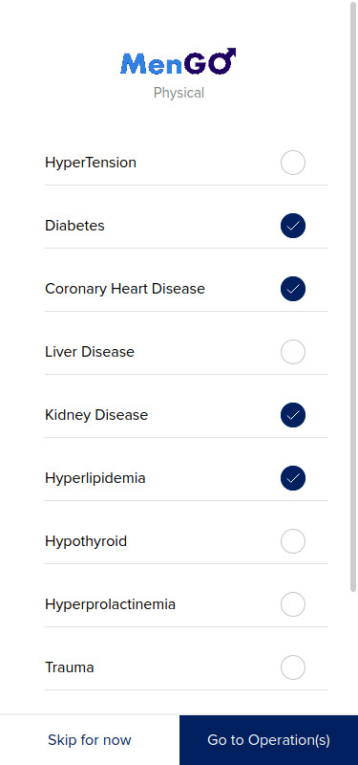 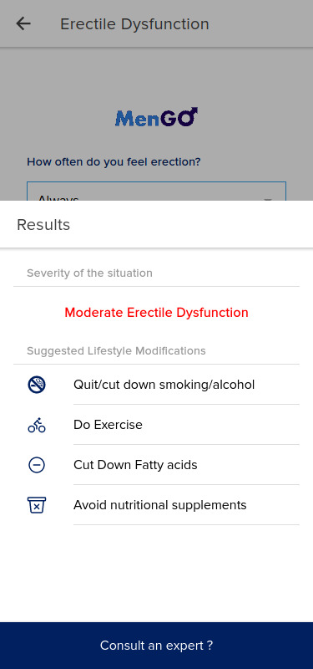

*(c) (d) (e)*

*Figures a-e: (a, b) Splash screens welcome the user who is logging in to the MenGO platform. (c) Various self-diagnostic tools which are available to the users of MenGO. (d) Users can update and modify their health profile after signing up or during application usage. (e) Users can get quick and effective diagnoses and prognoses via MenGO.*

**DISCUSSION**

In this manuscript, we have described the world's first mobile application dedicated to solving andrological diseases using a data science and AI-driven digital healthcare solution. Our solution is designed to address a multitude of andrological issues with a smart and innovative approach.

A revolution in the domain of digital health technologies has been reshaping the diaspora of medical science. Several new players have emerged in recent years in the medical domain which provides various services or technologies related to advanced and more accurate diagnosis, prediction, and treatment. Continuous feedback and monitoring by health professionals and users enhance the effectiveness and success of any digital health applications and products. MenGO is adapting to this dynamic diaspora of digital health with its unique proposition towards solving the andrological conundrum that the world is suffering from.

1. **Future Work**

MenGO, while potent in itself, can further prosper with a strong backing of existing public health infrastructures. Widespread adoption of MenGO can enable economies of scale to kick in and amplify the current small-scale benefits manifold, to benefit a larger sector of the populace.

In the future, we aim to integrate MenGO into existing public health infrastructures and use LSTM-GAN assisted automated voice consultations to provide low-cost specialist consultation over traditional cellular networks. This will enable users to seamlessly integrate into the MenGO Stack even if they do not have access to smartphones or high-speed internet. In addition to this, we aim to integrate the concept of in-house Machine and Human-Assisted Check-ups (MHAC), where users can integrate health and diagnostic information from wearable health devices and also call for in-house vital check-ups by registered nurses. This will complete the full cycle of MenGO, making it a truly comprehensive digital health platform.

In the future, we also aim to develop and integrate genomics-based predictive analytics, medical imaging-based early diagnosis, integrating wearable devices, and blockchain-based safe and secure record management.

1. **Social Impact**

The social impact of such a platform can be far-reaching. In several ways, this platform will be able to tackle several common, but systemic societal problems, some of which are listed below:

* 1. Divorces due to Andrological issues.
  2. General apathy and non-acceptance of sexual issues in men.
  3. Misinformation in the domain of Andrological health, spread largely from social media.
  4. High cost and regular overload of public health infrastructure.
  5. Religious and social conservation against the discussion of sexual health.
  6. Absence of adequate privacy for men with regards to their Andrological issues.
  7. Gynecological problems in women due to Andrological issues of their spouses.
  8. Psychological and physiological stress in men suffering from otherwise preventable Andrological issues.

**CONCLUSION**

We have developed an integrated cloud-based, statistical modeling assisted personalized Andrological health management system, coupled with NLP, LSTM, and GAN-assisted chatbots and expert systems to perform personalized medical analytics, prediction, secure medical record management, and secure doctor to patient remote consultation with a user-friendly user interface. This system is named “MenGO” and is capable of mitigating several systemic issues in the field of Andrology and men’s sexual wellness.

Male infertility could be triggered by genetic anomalies including mutation, karyotype abnormalities, microsatellite instability, Y chromosome microdeletions, etc. Our future goal includes incorporating genomic-based predictions in our application which could incorporate personalized data from a third party and further analyze and suggest the potential risk factors to the users. Image-based analytics of clinical data is increasingly becoming popular and relevant due to the advent of robust learning methodologies. Several newer technologies have emerged in recent years which utilize the knowledge of AI and machine learning to expedite the diagnostic ability and accuracy of andrological diseases. For example, sperm motility prediction based on deep learning using sperm motility videos [28]; AI-based detection of prostate and urothelial cancer [29], etc.

We are currently in the process of integrating and testing newer features in “MenGO” to enhance its effectiveness in the early diagnosis and prediction of a broad range of andrological disorders.

**ACKNOWLEDGEMENTS**

DR thanks Mississippi INBRE, funded by NIGMS of NIH under grant number P20GM103476 at Alcorn State University.

**DISCLOSURES**

The authors of this manuscript declare that there are no conflicts of interest related to this manuscript.

**REFERENCES**

1. Pizzol, Damiano, Mike Trott, Igor Grabovac, Lin Yang, Yvonne Barnett, Christopher Parris, Daragh T. McDermott et al. "Ejaculation disorders in male patients with cancer: a systematic review and meta-analysis of prevalence." The Journal of Urology (2021): 10-1097. <https://doi.org/10.1097/JU.0000000000002136>
2. Hui, J., He, S., Liu, R. et al. Trends in erectile dysfunction research from 2008 to 2018: a bibliometric analysis. Int J Impot Res 32, 409–419 (2020). <https://doi.org/10.1038/s41443-019-0161-8>
3. Gerbild, Helle, Kristina Areskoug Josefsson, Camilla Marie Larsen, and Birgitte Schantz Laursen. "Communication about physical activity to reduce vascular erectile dysfunction–A qualitative interview study among men in cardiac rehabilitation." Scandinavian Journal of Caring Sciences. <https://doi.org/10.1111/scs.13021>
4. D. F. Mobley, M. Khera, and N. Baum, "Recent advances in the treatment of erectile dysfunction," Postgraduate Medical Journal, vol. 93, no. 1105, pp. 679–685, Jul. 2017. Accessed: Aug. 1, 2021. [Online]. Available: <https://doi.org/10.1136/postgradmedj-2016-134073>
5. J. Hui, S. He, R. Liu, Q. Zeng, H. Zhang, and A. Wei, "Trends in erectile dysfunction research from 2008 to 2018: a bibliometric analysis," International Journal of Impotence Research, vol. 32, no. 4, pp. 409–419, Jun. 2019. Accessed: Aug. 1, 2021. [Online]. Available: <https://doi.org/10.1038/s41443-019-0161-8>
6. R. Shamloul and H. Ghanem, "Erectile dysfunction," The Lancet, vol. 381, no. 9861, pp. 153–165, Jan. 2013. Accessed: Aug. 1, 2021. [Online]. Available: <https://doi.org/10.1016/s0140-6736(12)60520-0>
7. A. Barbonetti, F. Cavallo, G. Felzani, S. Francavilla, and F. Francavilla, "Erectile Dysfunction is the Main Determinant of Psychological Distress in Men with Spinal Cord Injury," The Journal of Sexual Medicine, vol. 9, no. 3, pp. 830–836, Mar. 2012. Accessed: Aug. 1, 2021. [Online]. Available: <https://doi.org/10.1111/j.1743-6109.2011.02599.x>
8. J. Shah, "Erectile dysfunction through the ages," BJU International, vol. 90, no. 4, pp. 433–441, Aug. 2002. Accessed: Aug. 1, 2021. [Online]. Available: <https://doi.org/10.1046/j.1464-410x.2002.02911.x>
9. M. Gul, A. Carvajal, E. C. Serefoglu, S. Minhas, and A. Salonia, "European association of urology guidelines for sexual and reproductive health 2020: what is new?," International Journal of Impotence Research, vol. 32, no. 5, pp. 477–479, Jul. 2020. Accessed: Aug. 1, 2021. [Online]. Available: <https://doi.org/10.1038/s41443-020-0335-4>
10. Xu, Jiangnan, Chao Wang, Yuhui Zhang, Zekun Xu, Jun Ouyang, and Jianglei Zhang. (2021). Risk of osteoporosis in patients with erectile dysfunction: A PRISMA-compliant systematic review and meta-analysis." Medicine 100, no. 24. doi: [10.1097/MD.0000000000026326](https://dx.doi.org/10.1097%2FMD.0000000000026326)
11. Chen, Tony, Shufeng Li, and Michael L. Eisenberg.(2021) "The Association Between Hemoglobin A1c Levels and Inflatable Penile Prosthesis Infection: Analysis of US Insurance Claims Data." The Journal of Sexual Medicine. <https://doi.org/10.1016/j.jsxm.2021.03.077>
12. Pizzol, Damiano, Mike Trott, Igor Grabovac, Lin Yang, Yvonne Barnett, Christopher Parris, Daragh T. McDermott et al. (2021) "Ejaculation disorders in male patients with cancer: a systematic review and meta-analysis of prevalence." The Journal of Urology : 10-1097. <https://doi.org/10.1097/JU.0000000000002136>
13. Gerbild, Helle, Kristina Areskoug Josefsson, Camilla Marie Larsen, and Birgitte Schantz Laursen. (2021) "Communication about physical activity to reduce vascular erectile dysfunction–A qualitative interview study among men in cardiac rehabilitation." Scandinavian Journal of Caring Sciences. <https://doi.org/10.1111/scs.13021>
14. Towe, Maxwell, Akhil Peta, Russell G. Saltzman, Navin Balaji, Kevin Chu, and Ranjith Ramasamy. "The use of combination regenerative therapies for erectile dysfunction: rationale and current status." International Journal of Impotence Research (2021): 1-4. <https://doi.org/10.1038/s41443-021-00456-1>
15. Karakus, Serkan, Biljana Musicki, and Arthur L. Burnett. "Mirabegron improves erectile function in men with overactive bladder and erectile dysfunction: a 12-week pilot study." International Journal of Impotence Research (2021): 1-5. <https://doi.org/10.1038/s41443-021-00455-2>
16. Light, Alexander, Dost Jabarkhyl, Peter Gilling, Gincy George, Mieke Van Hemelrijck, Ben Challacombe, Sachin Malde, Rick Popert, Prokar Dasgupta, and Oussama Elhage. "Erectile Function Following Surgery for Benign Prostatic Obstruction: A Systematic Review and Network Meta-analysis of Randomised Controlled Trials." European Urology (2021). <https://doi.org/10.1016/j.eururo.2021.04.012>
17. Zhou, Yuliang, Shenghui Chen, Duanjun Zhang, Huiyu Lu, Wenliang Yao, Wanxue Jiang, Yinglv Yu, and Chaoren Jiang. "The efficacy and safety of acupuncture in the treatment of erectile dysfunction: A protocol for systematic review and meta-analysis." Medicine 100, no. 21 (2021). doi: 10.1097/MD.0000000000025892
18. Elbardisi, Haitham, Ahmad Majzoub, Christiana Daniel, Fadwa Al. Ali, Mohamed Elesnawi, Kareim Khalafalla, Ashok Agarwal et al. "Endocrine contribution to the sexual dysfunction in patients with advanced chronic kidney disease and the role of hyperprolactinemia." Andrologia (2021): e14135. <https://doi.org/10.1111/and.14135>
19. Schmid, Florian A., Ulrike Held, Daniel Eberli, Hans-Christoph Pape, and Sascha Halvachizadeh. "Erectile dysfunction and penile rehabilitation after pelvic fracture: a systematic review and meta-analysis." BMJ open 11, no. 5 (2021): e045117. <http://dx.doi.org/10.1136/bmjopen-2020-045117>
20. Zhang, Yuyang, Wei Zhang, Yutian Dai, Hui Jiang, and Xiansheng Zhang. "Serum Folic Acid and Erectile Dysfunction: A Systematic Review and Meta-Analysis." Sexual Medicine 9, no. 3 (2021): 100356. <https://doi.org/10.1016/j.esxm.2021.100356>
21. Kohn, Taylor P., Saneal Rajanahally, Wayne JG Hellstrom, Tung-Chin Hsieh, and Omer A. Raheem. "Global Trends in Prevalence, Treatments, and Costs of Penile Prosthesis for Erectile Dysfunction in Men." European Urology Focus (2021). <https://doi.org/10.1016/j.euf.2021.05.003>
22. von Büren, Moritz, Severin Rodler, Isabell Wiesenhütter, Florian Schröder, Alexander Buchner, Christian Stief, Christian Gratzke, Christian Wülfing, and Johannes von Büren. "Digital Real-world Data Suggest Patient Preference for Tadalafil over Sildenafil in Patients with Erectile Dysfunction." European Urology Focus (2021).<https://doi.org/10.1016/j.euf.2021.04.019>
23. Basourakos, Spyridon P., Keith J. Kowalczyk, Marcio Moschovas, Vanessa Dudley, Jonathan E. Shoag, Vipul Patel, and Jim C. Hu. "Robot-Assisted Radical Prostatectomy Maneuvers to Attenuate Erectile Dysfunction: Technical Description and Video Compilation." Journal of Endourology ja (2021).<https://doi.org/10.1089/end.2021.0081>
24. Kumar, Naina, and Amit Kant Singh. "Trends of male factor infertility, an important cause of infertility: A review of literature." Journal of human reproductive sciences 8, no. 4 (2015): 191.doi: 10.4103/0974-1208.170370
25. Babakhanzadeh, Emad, Majid Nazari, Sina Ghasemifar, and Ali Khodadadian. "Some of the factors involved in male infertility: a prospective review." International journal of general medicine 13 (2020): 29.doi: 10.2147/IJGM.S241099
26. Zhang, FP., Malinen, M., Mehmood, A. et al. Lack of androgen receptor SUMOylation results in male infertility due to epididymal dysfunction. Nat Commun 10, 777 (2019). <https://doi.org/10.1038/s41467-019-08730-z>
27. Dissanayake, D. M. I. H., Keerthirathna, W. L. R., & Peiris, L. D. C. (2019). Male infertility problem: a contemporary review on present status and future perspective. Gender and the Genome, 3, 2470289719868240.<https://doi.org/10.1177/2470289719868240>
28. Hicks, S.A., Andersen, J.M., Witczak, O. et al. Machine Learning-Based Analysis of Sperm Videos and Participant Data for Male Fertility Prediction. Sci Rep 9, 16770 (2019). <https://doi.org/10.1038/s41598-019-53217-y>
29. Hameed, B. M., S. Dhavileswarapu, V. L. Aiswarya, Syed Zahid Raza, Hadis Karimi, Harneet Singh Khanuja, Dasharathraj K. Shetty et al. "Artificial intelligence and its impact on urological diseases and management: A comprehensive review of the literature." Journal of Clinical Medicine 10, no. 9 (2021): 1864. <https://doi.org/10.3390/jcm10091864>